|  |  |
| --- | --- |
| \\VFILERDPI\DPI-Home\OBRIENR2\My Documents\Downloads\PP logo.jpg | Central Coast Council Logo |
| **MEMO TO PANEL**  HUNTER AND CENTRAL COAST REGIONAL PLANNING PANEL | |

|  |  |
| --- | --- |
| PANEL REFERENCE & DA NUMBER | PPSHCC-290 – Central Coast –  DA/320/2024 |
| PROPOSAL | Construction of Light Industrial Building (Nine Units) |
| ADDRESS | Lot 3 DP612071, 2 Brownlee Street, Ourimbah  Lot 4 DP1237817, 4 Brownlee Street, Ourimbah |
| APPLICANT | Central Coast Industry Connect C/- Interface Planning |
| OWNER | Central Coast Council |
| DA LODGEMENT DATE | 10 April 2024 |
| APPLICATION TYPE | Development Application – Nominated Integrated & Integrated |
| REGIONALLY SIGNIFICANT CRITERIA | Clause 3, Schedule 6 of *State Environmental Planning Policy (Planning Systems) 2021:* Council related development over $5 million |
| CIV | $10,546,126 (excluding GST) |
| RECOMMENDATION | Approval subject to conditions |
| PANEL MEETING DATE | 15 October 2024 |
| PREPARED BY | J Tattam - Senior Development Planner |
| DATE OF MEMO | 9 October 2024 |

**SUPPLEMENTARY INFORMATION**

This memo is to supplement the Officer’s report to the Panel to clarify and revise the comments and conditions in relation to Chapter 4 of *State Environmental Planning Policy (Resilience and Hazards)* following further consideration by assessment staff.

By way of background, the Applicant provided a Preliminary Site Investigation (PSI) and Detailed Site Investigation (DSI) in support of the proposal. The PSI identified the following four Areas of Environmental Concern (AECs) for the site:

1. Former sawmill/recycling depot;

2. Former use of Lot 42 as Council depot;

3. Abandoned dwelling on Lot 42; and

4. Fill materials.

The PSI recommended preparation of a DSI.

The DSI identified that two of the AECs – a former office building on western boundary, and a former waste/recycling area on the eastern portion of the site were inaccessible due to thick vegetation. The figures below from the DSI shows the inaccessible areas of the site.

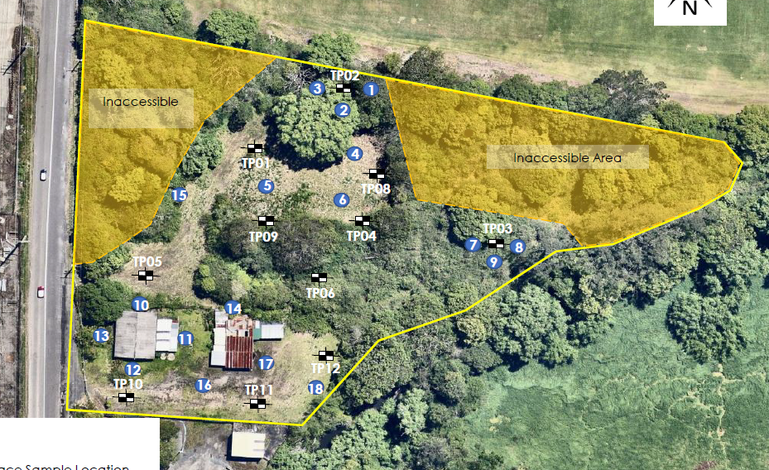

Figure 1: Figure 4 from the DSI

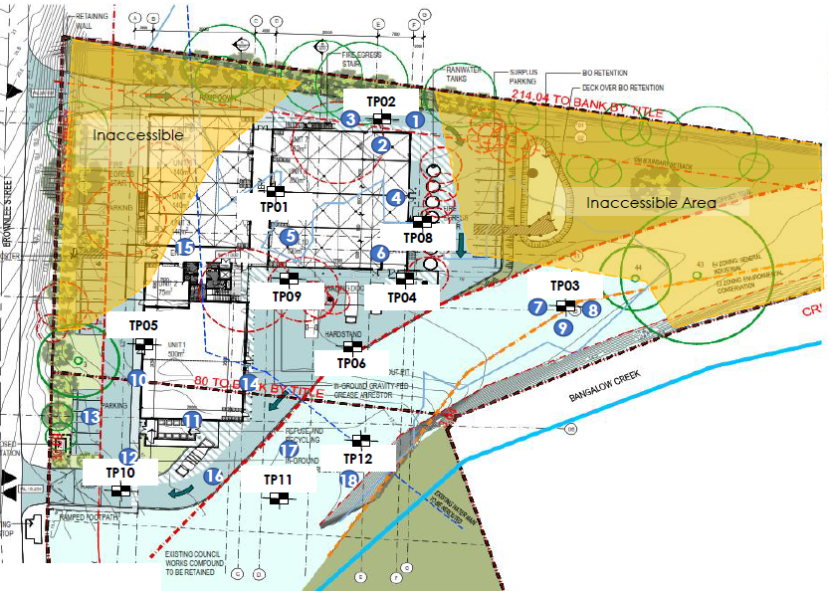

Figure 2: Figure 5 from the DSI

The DSI stated that:

*The former waste/recycling area is located within the 20m wide riparian zone along Bangalow Creek and the vegetated landscape area in the eastern portion of the site, where no development or vegetation clearing is proposed, other than weed management under a Vegetation Management Plan (VMP). Based on this, assessment for contamination in these areas is not considered to be warranted, and vegetation clearing for the purpose of contamination assessment is considered to pose a net adverse environmental impact.*

And

*The former office building on the western portion of the site poses a contamination risk from potential hazardous building materials (i.e. asbestos, lead paints). The footprint of the building was approximately 40m2. This area, and the proposed development areas of the site, will be covered with buildings and hardstand as part of the commercial/industrial development. Therefore, the potential risk this area poses to the development from a contamination perspective is low. Based on this, it is considered that this area could also be managed under the UFP.*

The DSI recommended that an Unexpected Finds Procedure is developed and that an environmental scientist is present during vegetation clearing and excavation for the proposed detention basin and associated drainage lines, and for the area of the former office building on the western portion of the site.

The report was finalised, and a set of conditions were drafted on this basis.

It is noted that these inaccessible areas include significant amounts of exotic species with pockets of native vegetation. Therefore, any disturbance/clearing required to conduct sampling would require prior development consent.

Council officers have further considered the draft recommended conditions with regard to the nominated inaccessible areas of the site under the DSI. As a consequence of conserving the ecological values of the site, while also meeting obligations under Chapter 4 of SEPP (Resilience and Hazards) 2021, the following further conditions are recommended During Works:

*4.7 Following vegetation clearing/tree removal works and prior to any construction works obtain Council approval of a supplementary Detailed Site Investigation and Site-Specific Risk Assessment and Modelling prepared by a suitably qualified contaminated land consultant that is accredited by the Certified Environmental Practitioners Scheme- Site Contamination (CEnvP(SC)) and/or the Certified Professional Soil Scientist- Contaminated Site Assessment and Manager (CPSS CSAM). Such investigation must be undertaken in accordance with Managing Land Contamination – Planning Guidelines SEPP 55 – Remediation of Land (1998) and NSW Environment Protection Authority’s Contaminated Land Guidelines - Consultants Reporting on Contaminated Land 2020 and Contaminated Sites – Sampling Design Guidelines (2022) and the National Environment Protection (Assessment of Site Contamination) Measure (ASC NEPM, 1999 as amended 2013).*

*Remedial Action Plan*

*(Where required) Obtain Council approval of a Remedial Action Plan prepared by a suitably qualified contaminated land consultant that is accredited by the Certified Environmental Practitioners Scheme- Site Contamination (CEnvP(SC)) and/or the Certified Professional Soil Scientist- Contaminated Site Assessment and Manager (CPSS CSAM). Such investigation must be undertaken in accordance with Managing Land Contamination – Planning Guidelines SEPP 55 – Remediation of Land (1998) and NSW Environment Protection Authority’s Contaminated Land Guidelines - Consultants Reporting on Contaminated Land 2020 and Contaminated Sites – Sampling Design Guidelines (2022) and the National Environment Protection (Assessment of Site Contamination) Measure (ASC NEPM, 1999 as amended 2013).*

*Validation Report, Environmental Management Plan and Ongoing Monitoring Report*

*(Where required) Obtain Council approval of a Validation Report, Environmental Management Plan and Ongoing Monitoring Report prepared by a suitably qualified contaminated land consultant that is accredited by the Certified Environmental Practitioners Scheme- Site Contamination (CEnvP(SC)) and/or the Certified Professional Soil Scientist- Contaminated Site Assessment and Manager (CPSS CSAM). Such investigation must be undertaken in accordance with Managing Land Contamination – Planning Guidelines SEPP 55 – Remediation of Land (1998) and NSW Environment Protection Authority’s Contaminated Land Guidelines - Consultants Reporting on Contaminated Land 2020 and Contaminated Sites – Sampling Design Guidelines (2022) and the National Environment Protection (Assessment of Site Contamination) Measure (ASC NEPM, 1999 as amended 2013).*

Clause (1) of Section 4.6 of SEPP (Resilience and Hazards 2021) states:

*(1)  A consent authority must not consent to the carrying out of any development on land unless—*

*(a)  it has considered whether the land is contaminated, and*

*(b)  if the land is contaminated, it is satisfied that the land is suitable in its contaminated state (or will be suitable, after remediation) for the purpose for which the development is proposed to be carried out, and*

*(c)  if the land requires remediation to be made suitable for the purpose for which the development is proposed to be carried out, it is satisfied that the land will be remediated before the land is used for that purpose.*

Where the inaccessible areas of the site are contaminated, the Panel can be satisfied that the land will be suitable, after remediation for the proposed Light Industrial purpose.

**Changes to Conditions**

**a) It is recommended that the following draft condition 4.7 is removed:**

*4.7. Engage an environmental scientist to be present during works associated with the Biodiversity Management Plan to ensure that the measures in the Unexpected Finds Protocol are adhered to.*

Reason – Concern is raised that this condition suggests an environmental scientist should be present for all works over the seven year period. The matter is better covered by the recommended condition below.

**b) The following replacement condition 4.7 is recommended (During Works):**

*4.7 Following vegetation clearing/tree removal works and prior to any construction works obtain Council approval of a supplementary Detailed Site Investigation and Site-Specific Risk Assessment and Modelling prepared by a suitably qualified contaminated land consultant that is accredited by the Certified Environmental Practitioners Scheme- Site Contamination (CEnvP(SC)) and/or the Certified Professional Soil Scientist- Contaminated Site Assessment and Manager (CPSS CSAM). Such investigation must be undertaken in accordance with Managing Land Contamination – Planning Guidelines SEPP 55 – Remediation of Land (1998) and NSW Environment Protection Authority’s Contaminated Land Guidelines - Consultants Reporting on Contaminated Land 2020 and Contaminated Sites – Sampling Design Guidelines (2022) and the National Environment Protection (Assessment of Site Contamination) Measure (ASC NEPM, 1999 as amended 2013).*

*Remedial Action Plan*

*(Where required) Obtain Council approval of a Remedial Action Plan prepared by a suitably qualified contaminated land consultant that is accredited by the Certified Environmental Practitioners Scheme- Site Contamination (CEnvP(SC)) and/or the Certified Professional Soil Scientist- Contaminated Site Assessment and Manager (CPSS CSAM). Such investigation must be undertaken in accordance with Managing Land Contamination – Planning Guidelines SEPP 55 – Remediation of Land (1998) and NSW Environment Protection Authority’s Contaminated Land Guidelines - Consultants Reporting on Contaminated Land 2020 and Contaminated Sites – Sampling Design Guidelines (2022) and the National Environment Protection (Assessment of Site Contamination) Measure (ASC NEPM, 1999 as amended 2013).*

*Validation Report, Environmental Management Plan and Ongoing Monitoring Report*

*(Where required) Obtain Council approval of a Validation Report, Environmental Management Plan and Ongoing Monitoring Report prepared by a suitably qualified contaminated land consultant that is accredited by the Certified Environmental Practitioners Scheme- Site Contamination (CEnvP(SC)) and/or the Certified Professional Soil Scientist- Contaminated Site Assessment and Manager (CPSS CSAM). Such investigation must be undertaken in accordance with Managing Land Contamination – Planning Guidelines SEPP 55 – Remediation of Land (1998) and NSW Environment Protection Authority’s Contaminated Land Guidelines - Consultants Reporting on Contaminated Land 2020 and Contaminated Sites – Sampling Design Guidelines (2022) and the National Environment Protection (Assessment of Site Contamination) Measure (ASC NEPM, 1999 as amended 2013).*

Reason – to satisfy the requirements of Chapter 4 of SEPP (Resilience and Hazards) 2021.

**c) The following condition 4.26 is recommended (During Works):**

*4.26* *Undertake works in accordance with the approved Unexpected Finds Protocol.*

Reason – To ensure that the Unexpected Finds Protocol is implemented.

**d) The following draft condition 2.22 is deleted:**

*2.22. Submit an amended Biodiversity Management Plan to Council’s Ecologist for approval that:*

1. *Identifies the subject site as per the approved Site Plan, and*
2. *Includes a detailed cost estimate from a qualified bush regenerator/other specialists to implement all management activities in full.*

Reason – The above condition was accidentally included on the draft consent twice. This is a repeat of Condition 2.21 and should be removed.

**The draft revised conditions in accordance with the above (with amendments in red) are attached to this memo.**